

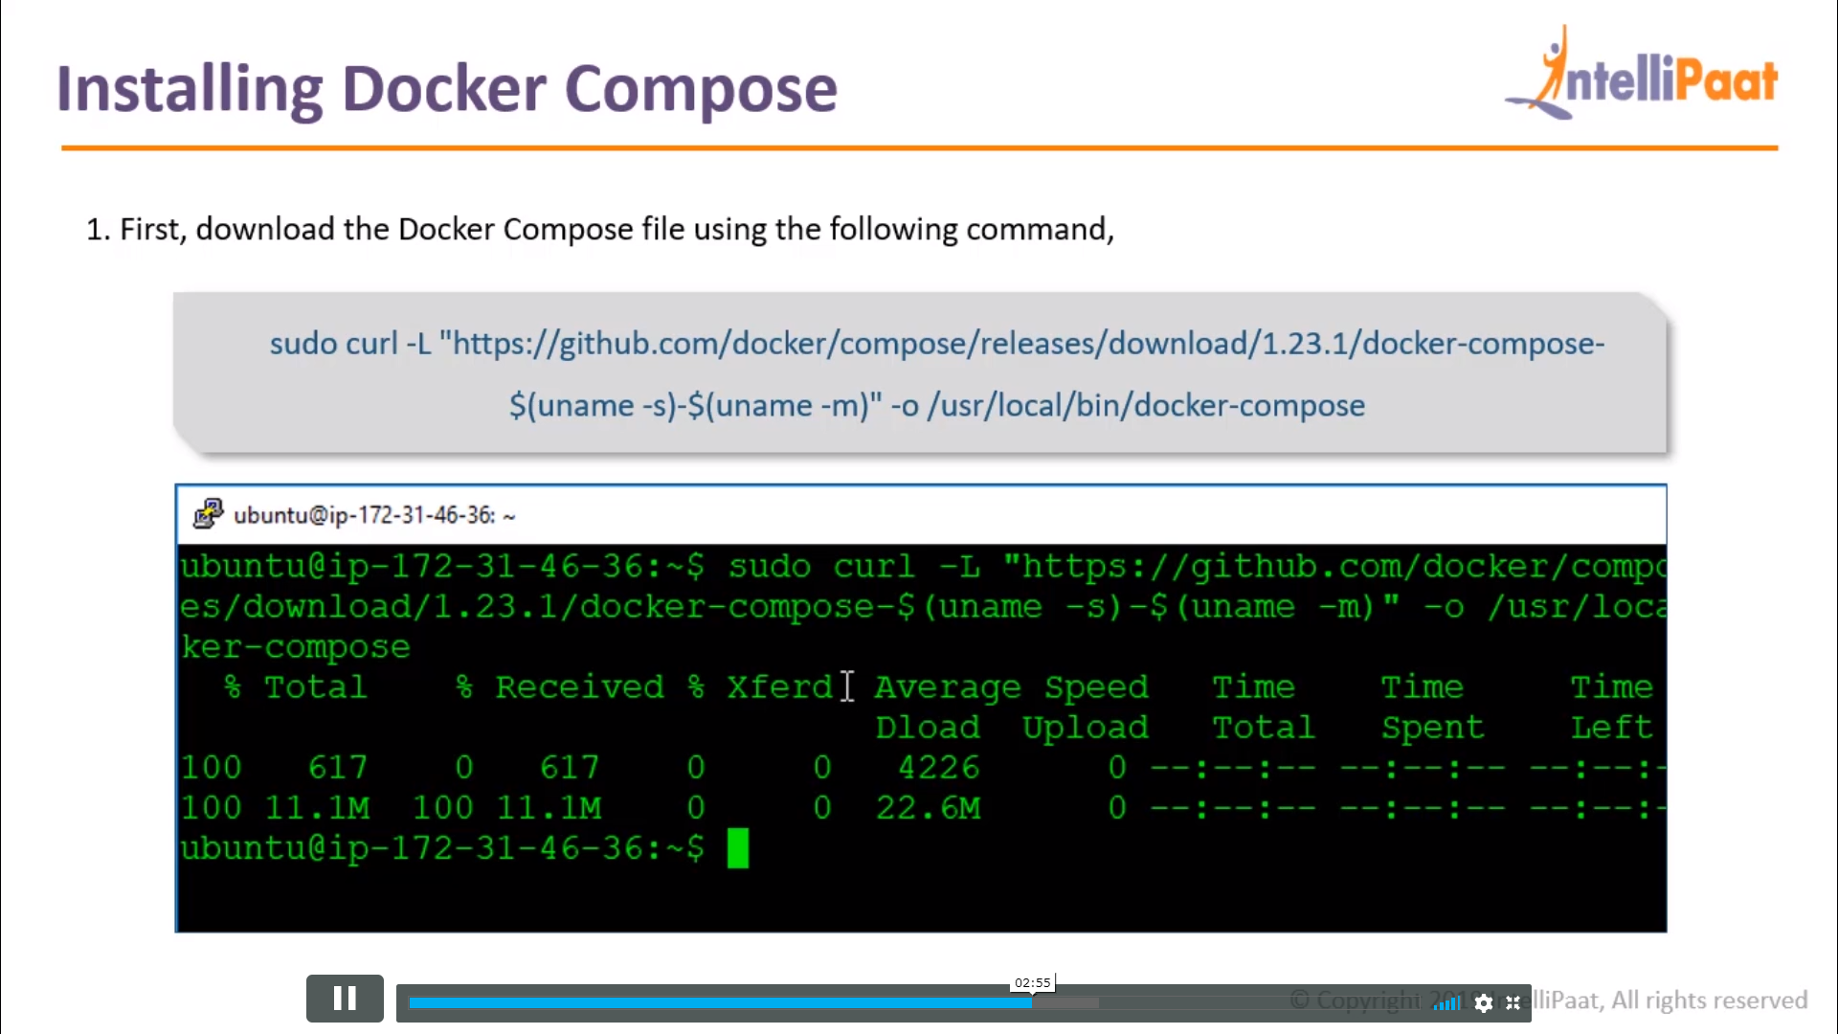

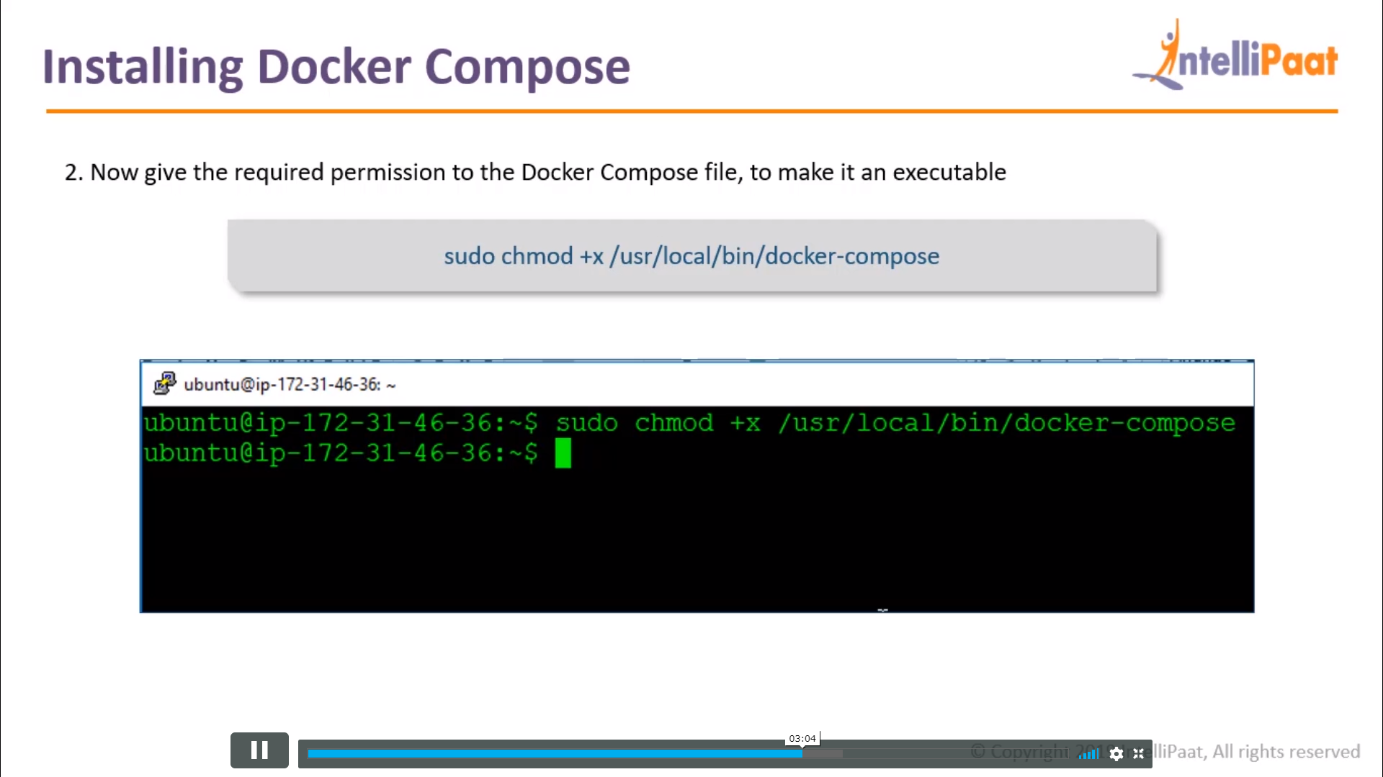

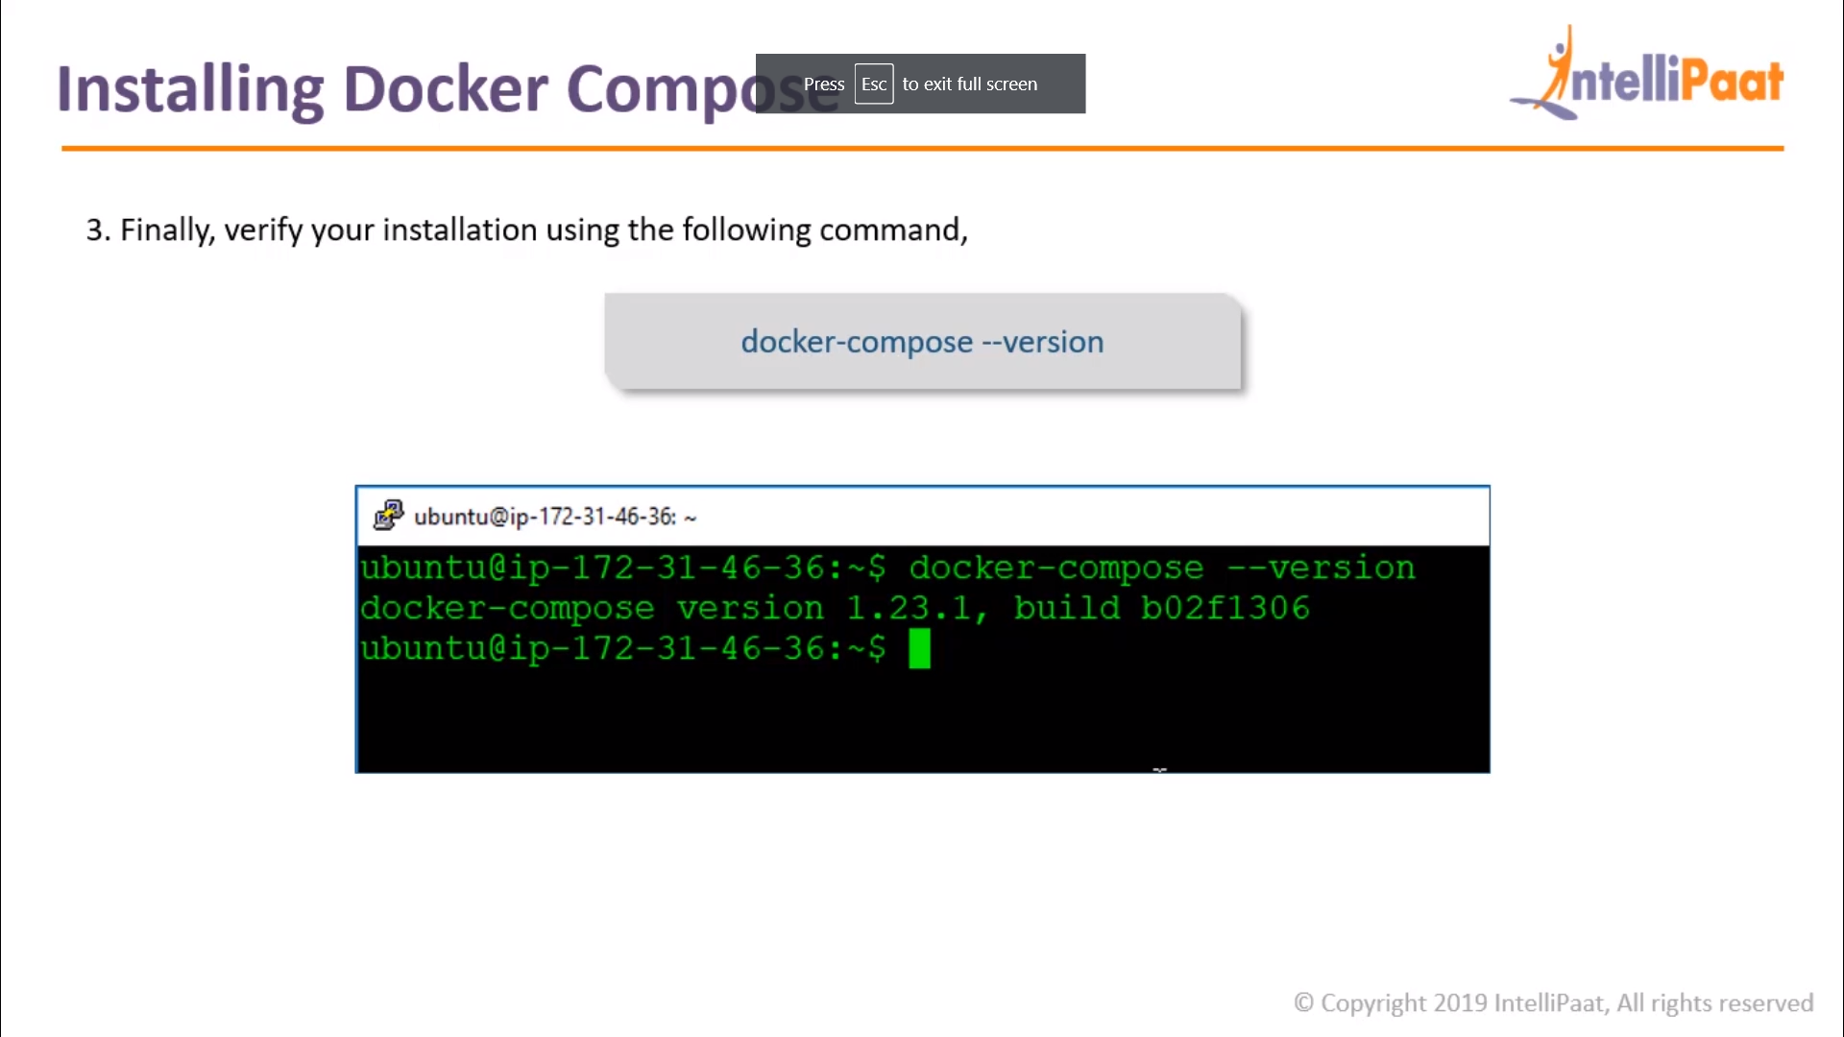

RUNNING A SAMPLE DOCKER COMPOSE FILE

Step 1: Create a folder called “docker”

$ sudo nano docker

Step 2: Write the sample YAML file in “docker-compose.yml” file

version: '3'

services:

sample1:

image: httpd

ports: - "5000:5000"

sample2:

image: nginx

docker swarm : availibity of continares , check their health , manging the continers

Machine scale set

Kuburnetes

Step 3: To build this docker-compose file the syntax is the following:

$ docker-compose up –d

Step 4: Ensure all your containers are running

$ docker ps